[This document is formatted according to the Seventh Edition APA Manual guidelines. To use this template, simply replace the text you see within brackets [example] with your own text. Take care not to delete any page breaks or to alter the margins or styles in the paper. However, do be sure to delete the instructions, comment bubbles, and brackets before you submit your paper.]

[Mastering the Rules of Professional Writing Takes Time]

[Your Name]
[Academic Department Name, Institution Name]
[Course Name]
[Instructor Name]
[Date]

[Mastering the Rules of Professional Writing Takes Time]
[Mastering the rules of professional writing can take years. Students seeking to learn how to write professionally should obtain resources on grammar, mechanics, and style (Marshall et al., 2019). Professional and academic writing should be clear and concise, and it should avoid the use of jargon, colloquial phrasing, and clichés. In addition, before completing a paper, it is helpful to create an outline. Following an outline can reduce the need for editing later. Finally, the professional writer should edit and proofread (Yes, they are two distinct steps in the writing process!) his or her document before submitting it for review.
Although mastering the rules of professional writing is time consuming, it is achievable for the dedicated student. The more you read and notice what comprises clear, concise academic writing, the easier it will become for you to produce similar writing. Of course, it takes practice as well. Be sure you take advantage of the resources available to you, included submitting your drafts to your campus writing center for review prior to submitting to your instructor.]
[First Main Level 1 Heading]
[You must have at least one paragraph of text between headings. If you are going to break the main sections up into subsections, then this opening paragraph should serve as a brief introduction to what the reader can expect to find in the following subsections. To learn about the formatting nuances of APA heading levels, see Table 1. Generally, a paragraph should have at least three sentences, and should include a main idea, or topic sentence, supporting evidence, author analysis, and lead in, or link, to the next paragraph.]
[Subheading 1]
[If you are breaking a main section (Level 1 Heading) down into two or more subsections, you’ll place your first subsection text here.]
[Subheading 2]
[Remember, you will only use subsection headings if breaking the preceding higher heading down into two or more subsections.]
[Second Main Level 1 Heading]
[Insert the opening for your second main point here. You will continue on with this organizational structure until your paper is complete. In addition to the main text of your paper, you might also be tasked with including tables and figures. Per APA (2020), these can appear either in appendices at the end of the paper (after the reference list) or can appear in the body of the paper. Regardless of where they appear, follow the formatting standards outlined here.]
Table 1
Seventh Edition APA Manual Heading Guidelines
Level | Explanation | Example
1 | Centered, bold, title case, text begins as a new paragraph | This is a Level 1 Heading  Paragraph begins here.
2 | Flush left, bold, title case, text begins as a new paragraph | This is a Level 2 Heading  Paragraph begins here.
3 | Flush left, bold italic, title case, text begins as a new paragraph | This is a Level 3 Heading  Paragraph begins here.
4 | Indented, bold, title case, end with a period, text begins same line | This is a Level 4 Heading. Paragraph begins here.
5 | Indented, bold italic, title case, end with a period, text begins same line | This is a Level 5 Heading. Paragraph begins here.
Note: Adapted from APA (2020).

Figure 1
How to Format In-Line and Parenthetical Citations
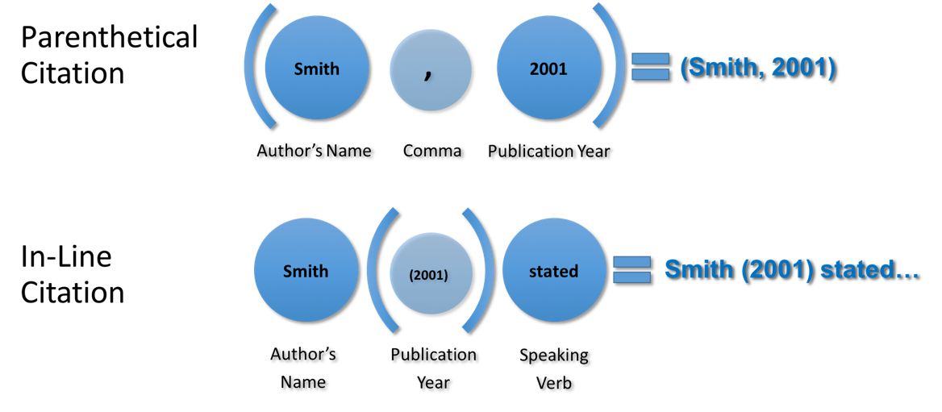
Note: Online Campus Writing Center (2019).
[Third Main Level 1 Heading]
[Text here.]

References
Marshall, H., Lynch, G., & Rasmussen, S. (2019). APA style and you. Website Name. http://www.fakeurl.com

Additional Reference List Rules
American Psychiatric Association. (2013). Diagnostic and statistical manual of mental disorders (5th ed.). Author.
Brown, A. E., & Garrett, J. W. (2000). Clinicians and the legal system: Testifying and everything else you need to know. Guilford.

